DESIGN AND IMPLEMENTATION OF ONLINE VOTING SYSTEM
(A CASE STUDY OF GOMBE STATE POLYTECHNIC BAJOGA)

BY

GROUP 15
S/N | NAMES | REGISTRATION NUMBER
 | BENJAMIN EMMANUEL | ND/CS/19/0284
 | ABUBAKAR HASSAN ZAGADA | ND/CS/19/0412
 | MOHAMMED BAWA | ND/CS/19/0102
 | BABA A. DANLADI | ND/CS/19/0185
 | ABDULLAHI MUHAMMAD | ND/CS/19/0542

A PROJECT SUBMITTED TO THE DEPARTMENT OF COMPUTER SCIENCE, SCHOOL OF SCIENCE AND TECHNOLOGY, GOMBE STATE POLYTECHNIC BAJOGA IN PARTIAL FULFILLMENT OF THE REQUIREMENT FOR THE AWARD OF NATIONAL DIPLOMA (ND) IN COMPUTER SCIENCE

MARCH, 2022

DECLARATION
We hereby declare that this work is the product of our research effort, under taken under the supervision of Mr. Joshua Umaru and has not been presented and will not be presented elsewhere for the award of ND certificate. All source have been duly acknowledged.
S/N | NAMES | SIGNATURE
 | BENJAMIN EMMANUEL
 | ABUBAKAR HASSAN ZAGADA
 | MOHAMMED BAWA
 | BABA A. DANLADI
 | ABDULLAHI MUHAMMAD

CERTIFICATION
This is to certify that the project titled “Online Voting System” was carried out under the supervision of:

………………………………… ………………………….………
MR. JOSHUA UMARU DATE
PROJECT SUPERVISOR

………………………………… ………………………….………
MR. IBRAHIM HASSAN DATE
HEAD OF DEPARTMENT

………………………………… ………………………….………
EXTERNAL EXAMINER DATE

ACKNOWLEDGMENT
Our deep gratitude goes to Almighty God the creator of the creation. This work is a synergistic product of many minds and we feel a deep sense of gratitude to our parents, brothers and sisters our friends for their encouragement and for being ever supportive. Our sincere thanks goes to our supervisor Mr. Joshua Umaru for his thorough assistance with this work.
We appreciate the effort and care of the Head of Computer Science Department Mal. Ibrahim Hassan. We also acknowledge the Computer Science Students (set 2021/2022) for their active verbal participation and suggestions towards the evolvement of this project work.

DEDICATION
We dedicated this work to our parents, our beloved once, the department of computer science and the computer scientists in general.

ABSTRACT
Fundamental right to vote or simply voting in elections forms the basis of democracy. The conduct of periodic, competitive, participatory, credible and non-violent elections is one of the main yardsticks used to determine the democratic condition of a state. In Nigeria, elections have been conducted using the manual system of voting ever since we started practicing democracy in 1999, but these elections using the manual means have been marred with a lot of electoral malpractices and hitches. These includes violent attack on the voters, result manipulations, vote buying, remoteness of polling centers etc. These are enough reasons that necessitates the design and construction of an electronic voting system, that goes a long way in addressing most of these problems. The online voting system aims to eliminate the bottlenecks evident in the manual voting system such as the lengthy registration process, unnecessary transportation, election violence and ultimately the incredibility of the votes. This was achieved by developing a time effective registration platform which registers a voter and assigns a voter their voters card immediately. The voter also gets to vote from their nearest safe and convenient dashboard and their votes gest counted immediately. The results obtained from subsequent tests were very impressive in terms of time, security and accuracy as compared to the manual system. Such system with all these capabilities will go a long in ameliorating the aforementioned problems of the existing manual system of voting in the Nigerian electoral process/system.

TABLE OF CONTENTS
DECLARATION ii
CERTIFICATION iii
ACKNOWLEDGMENT iv
DEDICATION v
ABSTRACT vi
LIST OF FIGURES xi
CHAPTER ONE 1
1.0 INTRODUCTION 1
1.1 BACKGROUND OF STUDY 1
1.2 STATEMENT OF THE PROBLEM 2
1.3 JUSTIFICATION OF THE STUDY 2
1.4 AIM AND OBJECTIVES 3
1.4.1 AIM 3
1.4.2 OBJECTIVES 3
1.5 SCOPE OF THE STUDY 3
1.6 LIMITATIONS OF THE STUDY 3
1.7 RESOURCES AND TECHNOLOGIES USED 4
1.8 DEFINITION OF TERMS 4
1.9 CHAPTERIZATION 5
CHAPTER TWO 7
LITERATURE REVIEW 7
2.1 THEORETICAL BACKGROUND 7
2.1.1 OVERVIEW OF TWO-FACTOR AUTHENTICATION 7
2.1.1.1 AUTHENTICATION FACTORS 8
2.1.2 SMART CARD TECHNOLOGIES 11
2.1.3 THE SMART CARD CHIP 12
2.1.4 DESCRIPTION OF SMART CARD PIN-OUT 12
2.1.5 ADVANTAGES OF SMART CARDS 13
2.1.6 DISADVANTAGES OF SMART CARDS 14
2.1.7 TYPES OF SMART CARDS 14
2.1.8 THE SMART CARD READER 16
2.1.9 FINGERPRINT AUTHENTICATION SYSTEM 17
2.1.9.1 FINGERPRINT SCANNER 18
2.1.9.2 PARTS OF A FINGERPRINT SCANNER 18
2.1.9.3 COMPONENTS OF A FINGERPRINT SYSTEM 19
2.1.9.4 MODE OF OPERATION OF A FINGERPRINT SYSTEM 20
2.1.9.5 APPLICATIONS OF FINGERPRINT BIOMETRIC TECHNOLOGIES 20
2.1.9.6 DISADVANTAGES OF FINGERPRINTS TECHNOLOGIES 22
2.2 REVIEW OF RELATED LITERATURES 23
2.2.1 REVIEW OF RELATED WORKS 23
2.2.1 SUMMARY OF THE REVIEWED LITERATURE 27
2.2.2 LITERATURE GAPS 27
CHAPTER THREE 28
METHODOLOGY 28
3.1 INRODUCTION 28
3.2 PRELIMINARY INVESTIGATION 28
3.3 FEASIBILITY STUDY 29
3.4 OVERVIEW OF THE EXISTING SYSTEM 29
3.5 ANALYSIS OF THE EXISTING SYSTEM 29
3.6 OVERVIEW OF THE PROPOSED SYSTEM 30
3.7 ANALYSIS OF THE PROPOSED SYSTEM 30
3.8 SYSTEM DESIGN 30
3.8.1 USE CASE DIAGRAM 31
3.8.2 SEQUENCE DIAGRAM 31
3.8.3 LOGICAL DESIGN 32
3.8.4 PHYSICAL DESIGN 33
3.8.5 DATABASE DESIGN 35
3.8.6 REQUIREMENTS ANALYSIS AND SPECIFICATION 36
3.8.7 SOFTWARE DESIGN 38
CHAPTER FOUR 39
SYSTEM IMPLEMENTATION TESTING 39
4.1 INTRODUCTION 39
4.1 SYSTEM IMPLEMENTATION 39
4.2 SYSTEM TESTING 39
4.2.1 ADMINISTRATOR DASHBOAR 41
CHAPTER FIVE 43
SUMMARY, CONCLUSION AND RECOMMENDATION 43
5.1 SUMMARY 43
5.2 CONCLUSION 43
5.3. RECOMMENDATION 44
REFERENCE 45
APPENDIX A 47
APPENDIX B 59

LIST OF FIGURES
Figure 2.1: RSA 9
Figure 2.2: A Pictorial representation of a Smart Card System 11
Figure 2.3: ISO-7816 standard pin-out of a basic Smart card chip 12
Figure 2.4: A Contact Smart Card. 15
Figure 2.5: A Contactless Smart Card 15
Figure 2.6: A Smart Card Reader and Writer 17
Figure 2.7: A Fingerprint Scanner 18
Figure 2.8: Block Diagram of a Fingerprint System. 19
Figure 2.11: A DRE Voting Machine 25
Figure 3.0: Use case diagram 31
Figure 3.1: Sequence diagram 31
Figure 3.2: Level 0 Dataflow Diagram for Online Voting 32
Figure 3.2: Level 1 Dataflow Diagram for Online Voting 32
Figure 3.3: System Flowchart 34
Figure 3.4: Hardware Block diagram 37
Figure 3.5: Software Design Block Diagram 38

LIST OF TABLES
Table 1: Admin Table 35
Table 2: Candidate Table 35
Table 3: Voters Table 36

CHAPTER ONE

1.0 INTRODUCTION
In every democratic setting with persons of differing and inconsistent opinions, decisions must be made between several options. This happens in business environment, educational environment, social organizations, and mostly in governance. One of the ways of making such a decision is through voting.
Voting is a formal process of expressing individual opinions for or against some motion. In the governance sector of many organisation this process is always used as a means of selecting or electing a leader. One of the key areas where voting is applied is in election. Election is the formal process of selecting a person for public office or of accepting or rejecting a political proposition by voting.
Online voting system is a software platform that allows registered voters to cast their votes. High quality online voting systems balance ballot security, accessibility and the overall requirements of an organization voting events. At their core, online voting systems protect the integrity of your vote by preventing voters from being able to vote multiple times. As a digital platform, they eliminate the need to gather in-person, cast votes using paper, or by any other means (e.g. email, insecure survey software).
You may hear an online voting system being referred to as an online election system, an online e voting system, or electronic voting. These all make reference to the same thing: a secure voting tool that allows your group to collect input from your group and closely scrutinize the results in real time.

1.1 BACKGROUND OF STUDY
This project describes an online voting system that was designed to meet the electoral needs and also tackles the inherent problems of the present manual voting system. This current system—manual voting—is characterized by absenteeism, inconvenience, long queues, stress, a lot of paper work, error-prone human effort involved in vote computation, omissions, delays and other election irregularities which plague the system and defeat the whole aim of voting (Kohno et al , 2004). In view of the rapid development of computer technology in virtually all fields of operations and its use in relation to information management, it has become pertinent to look into the development of an Online Voting System that can achieve the following:
i. Conduct free and fair election
ii. Safeguard data and information in the system.
iii. Reduce workload in the process of conducting elections.
iv. Keep accurate record of votes.
v. Reduce time wasted in announcing election results.
vi. Eliminate disenfranchising electorates.

1.2 STATEMENT OF THE PROBLEM
The present voting system applicable in the Nigerian electoral system has proved inefficient as the voters registration process is slow, the manual collation of results takes time and gives room for result manipulation, also the inaccessible nature of election venues which includes the long distances to be covered by voters to their registered location increases voters’ apathy towards the election processes, and finally the issues of ballot box snatching and damage and other election violence and issues associated with the traditional ballot paper voting all defiles the purpose of voting in election process as a formal process of expressing individual opinions for or against some motion.

1.3 JUSTIFICATION OF THE STUDY
The existing voting system encompasses a long process before the voting take place, a voter must register at the precise venue scheduled by the management, and the vote casting must be conducted in queue which result in high traffic to the areas with high population.
While the newly proposed system comes with the features that will overcome all the shortcomings of the existing system by giving the users ability to perform all the activities online.

1.4 AIM AND OBJECTIVES
In the quest to design a successful system to tackle the issues stated in the problem statement, the aim and objectives of the project are outlined below.

1.4.1 AIM
The aim of this project is to design and implement a low cost automated real-time e-voting system.

1.4.2 OBJECTIVES
Project Objectives includes
1. A detailed study of the election processes as it pertains to voting.
2. Design and develop a software platforms for voter registration, election voting, real-time election results collation and monitoring and mostly for voters remote access to elections.
3. Implement an automated/online voting system that should support multi-user environment.
4. Design and develop an administration dashboard for the election administrators.
5. Run simulations and compare the results of the designed e-voting system and other voting systems.
6. Validate the system to ensure that only legitimate voters are allowed to vote.

1.5 SCOPE OF THE STUDY
The proposed system is capable of allowing registered voters to cast votes online and also allowed the administrator to print the result after the completion of the election online.

1.6 LIMITATIONS OF THE STUDY
This project work is mainly designed to enable the Independent National Electoral Commission to use electronic device to capture voter’s information, and to allow voters to cast their votes easily and comfortably to promote a more credible election which is efficient and less costly. The dynamic nature of the elections application interface and database structure allows for different organizations set up and conduct basic elections too. It’s online interface enables real-time election monitoring and result collation. Some of its major limitations are:
1. It requires network access: Since the collation and sending of votes to the database requires an internet access which may not be readily available in some urban area would seem a limiting factor.
2. The cost of setting up an e-voting system is high: Due to the delicate nature of such a system and the fact that its’ major components are presently not locally source, it would be quite costly to setup, but its usage and maintenance cost is far better than the present ballot paper system.
3. It depends on electricity to a point: In as much as it has an in built battery that can last for the required election duration on daily basis, a case of low battery would require it to recharge, which may not be possible if there is no electric power at the moment.

1.7 RESOURCES AND TECHNOLOGIES USED
In this section the technologies used to develop this system will be described (both the hardware and software technologies). Regarding to software, the system was built using the following software Windows OS, Dream weaver and XAMP whereas the hardware consist of computer system using Windows OS.

1.8 DEFINITION OF TERMS
1. Candidate: Is a person who will contest for an election
2. Voter: Is person who will register to cast a vote to a particular candidate
3. Votes: a formal indication of a choice between two or more candidates or courses of action, expressed typically through a ballot or a show of hands.
4. DBMS - Database Management System
5. MySQL Cluster enables users to meet the database challenges of next generation web, cloud, and communications services with uncompromising scalability, uptime.
6. HTML: Hypertext Markup Language is the code that is used to structure a web page and its content. For example, content could be structured within a set of paragraphs, a list of bulleted points, or using images and data tables.
7. CSS: Cascading Style sheet is the language we use to style an HTML document.
8. PHP: Hypertext Preprocessor
9. Asynchronous JavaScript and XML is a set of web development techniques that uses various web technologies on the client-side to create asynchronous web applications.

1.9 CHAPTERIZATION
This project work on e-voting system is made up of five chapters: introduction, literature review, methodology and system design, systems implementation and result analysis, conclusion and recommendation. In the chapter one of this project, the introduction which briefly explains voting and elections in
general, is seen. It goes further to explain the background of an e-voting system, the aim and objectives of the e-voting system, its significance, scope, and constraints. It summaries; giving the project outline.
In the chapter two, a review of previous literature and technologies used for e-voting system was
treated. We also saw the different approaches to e-voting systems, their implementation, criticism with their literature reviews and noted the various gaps in the existing literatures.
In chapter three, we saw the block diagram of the project work, different methodologies used in development stages, the different phases of the project work which include its research, design, microcomputer programming, display programming, testing and fabrication. We extensively cover the requirements of the project, the mathematical models used, computer algorithms, designs and software incorporated in the work.
In chapter four, we talked about the steps taken and techniques used for the actual implementation of the project. We saw tests carried out to ensure that the project is efficient and also display the result gotten and their significance. We also saw the problems encountered and the techniques and solutions taken to overcome them or not. This chapter also sees the detailed analysis of the system. And finally, in chapter five, we concluded the work and gave notable recommendations for optimal operation of the product. Also we provided suggestions for improvement, enhancement and optimization of our existing work. We also outlined the major contribution to the body of knowledge in which our work has achieved.

CHAPTER TWO

LITERATURE REVIEW

2.1 THEORETICAL BACKGROUND

2.1.1 OVERVIEW OF TWO-FACTOR AUTHENTICATION
Two-factor authentication (also known as 2FA) is a type, or subset, of multi-factor authentication. Multi-factor authentication is an authentication method in which a computer user is granted access only after successfully presenting two or more pieces of evidence (or factors) to an authentication mechanism, knowledge (something the user and only the user knows), possession (something the user and only the user has), and inherence (something the user and only the user is). Hence, 2FA is a method of confirming users' claimed identities by using a combination of two different factors: 1) something they know, 2) something they have, or 3) something they are. A good example of two-factor authentication is the withdrawing of money from an ATM; only the correct combination of a bank smart card (something the user possesses) and a PIN (something the user knows) allows the transaction to be carried out. Two other examples are to supplement a user-controlled password with a one-time password (OTP) or code generated and received by user (e.g a security token ) on smartphone that only the user possesses.
Another subset is Two-step verification or two-step authentication which is a method of confirming a user's claimed identity by utilizing something they know (password) and a second factor other than something they have or something they are. An example of a second step is the user repeating back something that was sent to them through an out-of-band mechanism. Also, the second step might be a six digit number generated by another system that is common to the user and the authentication system.

2.1.1.1 AUTHENTICATION FACTORS
The use of multiple authentication factors to prove one's identity is based on the premise that an unauthorized user is unlikely to be able to supply the factors required for access. If, in an authentication attempt, at least one of the components is missing or supplied incorrectly, the user's identity is not established with sufficient certainty and access to the system (e.g a building, or data,) being protected by multi-factor authentication then remains blocked. The authentication factors of a multi-factor authentication scheme may include:
1. Some physical object in the possession of the user, such as a USB stick with a secret token, a bank smart card, a key, etc.
2. Secret known to the user, such as a password, PIN (Personal Identity Number).
3. Some physical characteristic of the user (biometric), such as a fingerprint, eye iris, voice, typing speed, pattern in key press intervals, etc.
4. Somewhere you are, such as connection to a specific computing network or utilizing a GPS signal to identify the location.
The above authentication factors are further discussed under the following sub headings:
1. Knowledge Factors
2. Possession Factors
3. Inherent Factors
4. Location Based Factors
1. Knowledge Factors: are the most commonly used form of authentication. In this form, the user is required to prove knowledge of a secret in order to authenticate. A password is a secret word or string of characters that is used for user authentication. This is the most commonly used mechanism of authentication. Many multi-factor authentication techniques rely on password as one factor of authentication. Variations include both longer ones formed from multiple words (a passphrase) and the shorter, purely numeric, personal identification number (PIN) commonly used for ATM access.
Traditionally, passwords are expected to be memorized. Many secret questions such as "Where were you born?" are poor examples of a knowledge factor because they may be known to a wide group of people, or be able to be researched.
2. Possession Factors: ("something the user and only the user has") have been used for authentication for centuries, in the form of a key to a lock. The basic principle is that the key embodies a secret which is shared between the lock and the key, and the same principle underlies possession factor authentication in computer systems. A security token is an example of a possession factor. Possession factors could be grouped as follows:
i. Disconnected tokens.
ii. Connected tokens.
iii. Software tokens.
Disconnected tokens have no connections to the client computer. They typically use a built-in screen to display the generated authentication data, which is manually typed in by the user.
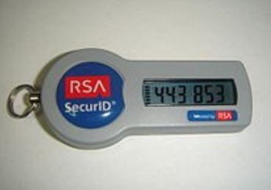

Figure 2.1: RSA
SecurID token, is an example of a disconnected token generator.
Connected tokens are devices that are physically connected to the computer to be used. Those devices transmit data automatically. There are a number of different types, including card readers, wireless tags and USB tokens.
- Software token (a.k.a. soft token) is a type of two-factor authentication security device that may be used to authorize the use of computer services. Software tokens are stored on a general-purpose electronic device such as a desktop computer, laptop, or mobile phone and can be duplicated.
(Contrast hardware tokens, where the credentials are stored on a dedicated hardware device and
therefore cannot be duplicated, absent physical invasion of the device.) A soft token may not be a
device the user interacts with. Typically an X.509v3 certificate is loaded onto the device and stored securely to serve this purpose.
3. Inherent Factors: are factors associated with the user, and are usually biometric methods, including fingerprints, face, voice, or iris recognition. Behavioral biometric such as keystroke dynamics can also be used.
4. Location Based Factors: Increasingly, a fourth factor is coming into play involving the physical location of the user. While hard wired to the corporate network, a user could be allowed to authenticate utilizing only a pin code while off the network entering a code from a soft token as well could be required. This could be seen as an acceptable standard where access into the office is controlled.
Systems for network admission control work in similar ways where your level of network access can be contingent on the specific network your device is connected to, such as WIFi vs wired connectivity.
This also allows a user to move between offices and dynamically receive the same level of network access in each.
Authentication is an important security feature in systems and should be further enhanced with two layer authentication which creates added trust to the overall integrity of the system.

2.1.2 SMART CARD TECHNOLOGIES
A smart card, typically a type of chip card, is a plastic card that contains an embedded computer chip– either a memory or microprocessor type–that stores and transacts data. This data is usually associated with either value, information, or both and is stored and processed within the card's chip. The card’s data is transacted via a reader that is part of a computing system.
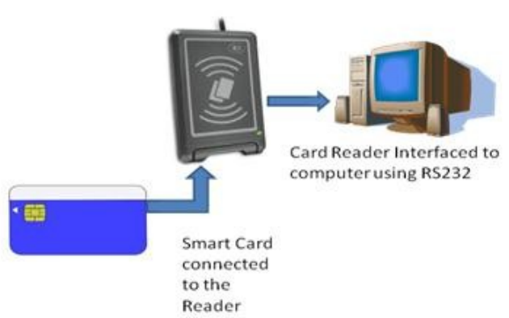

Figure 2.2: A Pictorial representation of a Smart Card System
Systems that are enhanced with smart cards are in use today throughout several key applications, including healthcare, banking, governance, entertainment, and transportation. All these applications can benefit from the added features and security that smart cards provide. Smart cards belong to the family of machine readable cards used for authentication, though markets that have been traditionally served by other machine readable card technologies, such as bar-code and magnetic stripe, and conventional authentication means, such as password and forms, are converting to smart cards as the calculated return on investment is revisited by each card issuer year after year.
ISO/IEC is one of the worldwide standard-setting bodies for technology, including plastic chip cards.
The primary standards for smart cards are ISO/IEC 7816, ISO/IEC 14443, ISO/IEC 15693 and
ISO/IEC 7501. These standards define the physical dimensions, the electrical interface, the
communication protocols and the database structure approach. A smart card system is consist mainly of a smart card and a card reader.

2.1.3 THE SMART CARD CHIP
The smart card uses the same standard plastic media as magnetic stripe based cards to carry the electronic chip: eight gold platted contacts are used to connect the silicon to the external world. These contacts are arranged according to the ISO7816-1 specification as shown in figure 2.3 below.
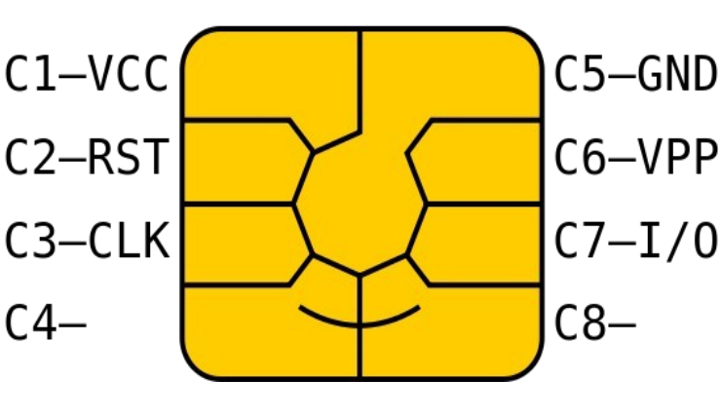

Figure 2.3: ISO-7816 standard pin-out of a basic Smart card chip

2.1.4 DESCRIPTION OF SMART CARD PIN-OUT
1. C1 (VCC +5V DC) : For power supply input (optional use by the card)
2. C2 (RESET) : Reset signal, used to reset the card's communications. Either used itself (reset signal supplied from the interface device) or in combination with an internal reset control circuit (optional use by the card). If internal reset is implemented, the voltage supply on Vcc is
mandatory
3. C3 CLOCK : Provides the card with a clock signal, from which data communications timing is
derived
4. C4 (RESERVED AUX1): Optionally used for USB interfaces and other uses.
5. C5 (GND): Ground (reference voltage)
6. C6 (Vpp): Programming voltage input (optional). This contact may be used to supply the voltage required to program or to erase the internal non-volatile memory. ISO/IEC 7816-3:1997 designated this as a programming voltage: an input for a higher voltage to program persistent memory (e.g., EEPROM). ISO/IEC 7816-3:2006 designates it SPU, for either standard or proprietary use, as input and/or output.
7. C7 (I/O) : Input or Output for serial data (half-duplex) to the integrated circuit inside the card.
8. C8 (RESERVED AUX2): Optionally used for USB interfaces and other uses.

2.1.5 ADVANTAGES OF SMART CARDS
1. Smart cards can provide a higher level of security than magnetic stripe cards as they can contain microprocessors capable of processing data directly without remote connections.
2. Smart cards are typically made of plastic, generally polyvinyl chloride and is of dimension
85.60 by 53.98 millimeters, which makes them portable and very easy to carry about.
3. Another advantage of smart cards is that once information is stored on a smart card, it can't easily be deleted, erased or altered. As such, smart cards are good for storing valuable data that can't be – or shouldn't be -- easily reproduced.
4. Smart card technology is generally safe against electronic interference and magnetic fields, unlike magnetic stripe cards. In addition, applications and data on a card can be updated through secure channels so issuers do not necessarily have to issue new cards when an update is necessary.
5. Multi-service smart card systems can enable users to access more than one different service with just one smart card.
6. The cost a smart card is very affordable and it is not costly to implement and manage.

2.1.6 DISADVANTAGES OF SMART CARDS
1. While smart cards have many advantages, the cards themselves -- as well as the smart card readers -- can be expensive as it is not locally sourced in Nigeria at the moment.
2. Another disadvantage of smart cards is that not all smart card readers are compatible with all types of smart cards. With multiple types of smart cards available, some use nonstandardprotocols for data storage and card interface; some smart cards and readers also use proprietary software that is incompatible with other readers.
3. While smart cards can be more secure for many applications, they are still vulnerable to certain types of attack. Attacks that can recover information from the chip are possible against smart card technology. Differential power analysis can be used to deduce the on-chip private key used by public key algorithms. Some implementations of symmetric ciphers can be vulnerable to
timing attacks or differential power analysis as well.
4. Smart cards may also be physically disassembled in order to gain access to the on-board microchip.

2.1.7 TYPES OF SMART CARDS
Smart cards can be categorized on different criteria including by how the card reads and writes data, by the type of chip implanted in the card and by the capabilities of that chip [4]. Some of the different of types of smart cards include:
1. Contact smart cards are the most common type of smart card. Contact smart cards are inserted into a smart card reader that has a direct connection to a conductive contact plate on the surface of the card. Commands, data and card status are transmitted over these physical contact points.
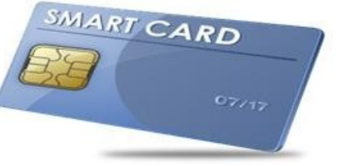

Figure 2.4: A Contact Smart Card.
2. Contactless smart cards require only close proximity to a card reader to be read; no direct contact is necessary for the card to function. The card and the reader are both equipped with antennae and communicate using radio frequencies over the contactless link. A contactless smart card functions by being put near the reader to be read.
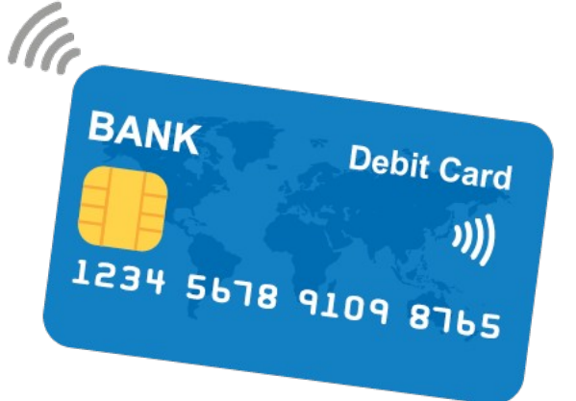

Figure 2.5: A Contactless Smart Card
3. Dual-interface cards are equipped with both contactless and contact interfaces. This type of card enables secure access to the smart card's chip with either the contactless or contact smart card interfaces.
4. Hybrid smart cards contain more than one smart card technology. For example, a hybrid smart
card might have one embedded processor chip that is accessed through a contact reader as well as an RFID enabled chip used for proximity connection. The two different chips may be used for different applications linked to a single smart card, as when the proximity chip is used for physical access to restricted areas while the contact smart card chip is used for single sign-on authentication.
5. Memory smart cards contain memory chips only and can only store, read and write data to the chip; the data on memory smart cards can be over-written or modified, but the card itself is not programmable so data can't be processed or modified programmatically. Memory smart cards can be read-only and used to store data such as a PIN, password or public key; they can also be read-write and used to write or update user data. Memory smart cards can be configured to be rechargeable or disposable, in which case they contain data that can only be used once or for a limited time before being updated or discarded.
6. Microprocessor smart cards have a microprocessor embedded onto the chip in addition to memory blocks. A microprocessor card may also incorporate specific sections of files where each file is associated with a specific function. The data in the files and the memory allocation are managed with a smart card operating system. This type of card can be used for more than one function and is usually designed to enable adding, deleting and otherwise manipulating data in memory.
Smart cards can also be categorized by their application, such as credit card, debit card, entitlement or other payment card, authentication token and so on.

2.1.8 THE SMART CARD READER
Smart card reader provides a path for an application to send and receive commands from the smart card. Smart card readers obtain or “read” data from smart card. They serve as an interface between the smart card and the micro-controller system. These easy-to-install devices read the data that is stored on contact or contactless 13.56 MHz smart cards. The main purpose of the smart card reader interface is two fold:
i. To provide the right power supply voltage to the card, whatever be the external power source
value.
ii. To translate the voltage levels necessaries to connect the card (pins C1 to C8) to the external
controller.
On the other hand, most of the smart card readers serve as writers too and the interface shall support the ISO7816-3 and EMV specifications.
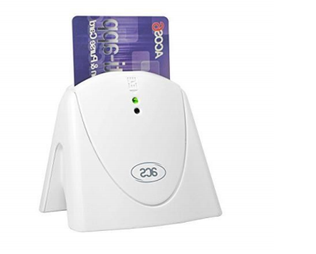

Figure 2.6: A Smart Card Reader and Writer

2.1.9 FINGERPRINT AUTHENTICATION SYSTEM
Biometric is a rapidly advancing field that is concerned with identifying a person based on his or her physiological or behavioral characteristics. Examples of automated biometric include fingerprint, face, iris, and speech recognition. Because a biometric property is an intrinsic property of an individual, it is difficult to surreptitiously duplicate and nearly impossible to share. The greatest strength of biometric, the fact that the biometric does not change over time, is at the same time its greatest liability.
Once a set of biometric data has been compromised, it is compromised forever.
A fingerprint is the composition of many ridges and furrows. Fingerprints can be distinguished by Minutia, which are some abnormal points on the ridges. Minutia is divided in to two parts such as: termination and bifurcation. Termination is also called ending and bifurcation is also called branch.
Fingerprint recognition or fingerprint authentication refers to the automated method of verifying a match between two human fingerprints. A fingerprint impression is acquired, typically using an ink-less scanner. The digital image of the fingerprint includes several unique features in terms of ridge bifurcations and ridge endings, collectively referred to as minutia.

2.1.9.1 FINGERPRINT SCANNER
A fingerprint scanner is an electronic device used to capture a digital image of the fingerprint pattern. The analysis of fingerprints for matching purposes generally requires the comparison of several features of the print pattern. These include patterns, which are aggregate characteristics of ridges, and minutia points, which are unique features found within the patterns.
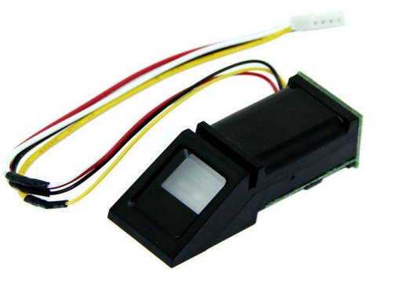

Figure 2.7: A Fingerprint Scanner

2.1.9.2 PARTS OF A FINGERPRINT SCANNER
The fingerprint scanner consists of fingerprint sensor, ADC (Analog to Digital Converter), flash ROM and DSP (Digital Signal Processing) chip.
1. Fingerprint Sensor: The fingerprint sensor is used for scanning the finger impression. The scanning data is in the form of analog. Further, this process is converted by the A/D converter.
2. A/D Converter: Here the analog data from the sensor is converted to the digital data and it is
transferred to the processor.
3. Flash ROM: The flash ROM is used to store the data temporarily in the DSP processor and this will work until the data is transferred to the main memory of the host.
4. DSP Chip: The DSP chip is used for processing and receiving the data. For further transfer of data the DSP port is used.
5. DSP Port: It is used for the communication between DSP processor and memory (database).

2.1.9.3 COMPONENTS OF A FINGERPRINT SYSTEM
A typical fingerprint system consist of four major components, which consist of:
1. Image capture
2. Feature extraction
3. Pattern matching
4. Database
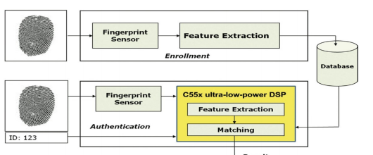

Figure 2.8: Block Diagram of a Fingerprint System.
Fingerprint systems translate illuminated images of fingerprints into digital code for further software such as enrollment (fingerprint registration) and verification (authentication or verification of registered users). The scanner uses an advanced CMOS image sensor to capture high contrast, high resolution fingerprint images that are virtually distortion-free. A series of powerful algorithms extract data from the image, mapping the distinguishing characteristics of the fingerprint.
This data is then converted into an encoded binary string known as a digital template, and stored in a database. The actual fingerprint image is never stored. To identify or verify a fingerprint, a proprietary matching algorithm compares the new template made from the extracted characteristics from the input fingerprint on the optical module to a previously stored sample. The entire matching process takes roughly one second. Authentication takes place locally at the device or on a server, depending on system configuration.

2.1.9.4 MODE OF OPERATION OF A FINGERPRINT SYSTEM
A fingerprint biometric system can operate in two modes:
1. Verification mode: The system performs a one-to-one (1:1) comparison of a captured fingerprint with a specific template stored in the database in order to verify the individual is the person they claim to be.
2. Identification mode: The system performs a one-to-many (1:N) comparison against fingerprints in the database in an attempt to establish the identity of an unknown individual.

2.1.9.5 APPLICATIONS OF FINGERPRINT BIOMETRIC TECHNOLOGIES
There are numerous applications for the use of Biometric Technology, but the most common ones are as follows:
1. Logical Access Control: This refers to gaining access to a computer network either at the place
of the business or corporation or via a secured remote connection from a distant location. Fingerprint systems are deployed to allow for easy access for authenticated users.
2. Physical Access Control: refers to giving a person or an employee of a business or a corporation
access to a secure building, or even a secure office from within it. Fingerprint systems are installed at entrance points to grant entrance access to only authentic employers or person with such access or clearance.
3. Time and Attendance: Here, fingerprint biometric is used to take records of attendance of the
members of an organisation. The time of arrival and departure can also be recorded and stored in a database for reference purposes.
4. Law Enforcement: This is the most widely known application of fingerprint biometric technologies. Here law enforcement agencies implement fingerprint biometric system as a means of collecting identities of criminals. IAFIS (Integrated Automated Fingerprint Identification System), a worldwide database of fingerprints of criminals is an example of such.
IAFIS administrated and maintained by the FBI (Federal Bureau of Investigation) in the United
States.
5. Surveillance: This is simply keeping tabs of a large group of people, and from there, determining any abnormal behavior from an established baseline. Fingerprint systems are deployed also with face recognition to track for example people with criminal records any erratic behavior. 2.1.3.6 Advantages of Fingerprints Technologies
1. Fairly small storage space is required for the biometric template, reducing the size of the
database required.
2. It is one of the most developed biometrics.
3. Each and every fingerprint including all fingers are unique, even identical twins have different
fingerprints and as such it is a safe way of identifying individuals.
4. Sound potential for forensic use as most of the countries have existing fingerprint databases.
5. Relatively inexpensive and offers high levels of accuracy.

2.1.9.6 DISADVANTAGES OF FINGERPRINTS TECHNOLOGIES
1. Even with its many benefits, fingerprint systems are also associated with some disadvantages
that makes their implementation controversial, and they includes:
2. The fingerprint scanner does not take into consideration when a person physically changes. Changes such as growth tends to change fingerprints and accidents such as bruises or cuts or even dirt on the finger can make an already existing user’s verification invalid as the fingerprint is now altered.
3. For some people it is very intrusive, because is still related to criminal identification.
4. If anyone can access to an authorized user’s prints, he can trick the scanner. The criminal can
cut off somebody’s finger to get a scanner security system but some scanners have additional pulse and heat sensors to verify that the finger is alive, but these systems can still be fooled by a
gelatin print mold over a real finger.
5. Having a high security system may require expensive computer hardware and software, certain fingerprint scanners can be quite expensive.
Fingerprint authentication is the cheapest, fastest, most convenient and most reliable way to identify a particular person. It has many functional advantages over traditional systems such as passwords. The greatest strength of the fingerprint authentication technology, is the fact that the fingerprint does not change over time.
Today, fingerprint recognition technology is used for mostly security and identification purpose. As fingerprint recognition technology develops, it is expected that more affordable and more portable fingerprint recognition devices will become available, and fingerprint recognition will be considered a safe and convenient authentication system.

2.2 REVIEW OF RELATED LITERATURES
Polling place e-voting and remote i-voting (Internet voting) systems of election have been used in different democratic societies. The United States, Australia, Estonia, Japan, Brazil and India are at various stages of e-voting adoption. In Africa, Namibia was the first country to transit to e-voting in its 2014 general elections. In Nigeria, Kaduna State is the first state to adopt an e-voting system in her Local Government elections in 2018.
The advantage of e-voting over the conventional voting system is obviously seen. Convenience is an attribute of e-voting that enhances participation and remedies apathy associated with traditional voting methods. E-voting makes it easier for people to make their views known and cast their votes, an important requisite for a constructive democratic process. Furthermore, poorly designed paper ballots, which might have been filled in or counted incorrectly becomes a thing of the past if e-elections are adopted.

2.2.1 REVIEW OF RELATED WORKS
In the past years, a lot of work has been carried out by people all over the world with respect to
developing an efficient e-voting system for election purpose. Some of these works will now be
reviewed. In the Brazilian e-voting machines are used for voter identification, vote casting and tallying. Political parties have access to the voting machines programs for auditing. The voting system has been widely accepted, since it speeds up the vote count tremendously and helps preventing fraud. Initially a paper trail was included in the e-voting systems. However, this was abandoned later due to technical problems associated with the printers. The missing of a paper trail is sometimes criticized since vote auditing is deemed impossible. Critics argue that this makes the whole process highly dependent on trusting the software. The Brazilian Supreme Electoral Court regularly funds research aimed at improving security. E.g. in 2009, a hacking competition was organized to create additional confidence in the technology. The Electoral Court started implementing biometric identification in the electoral process in 2012.
In Estonia, the National Electoral Committee started the actual e-voting project. A public procurement procedure was carried out and the Estonian company Cybernetica Ltd. was mandated with the development of the e-voting system. The system includes the use of smart cards and electronic signatures. In late 2004 the first test of the whole e-voting system took take place during a consultative referendum in the capital city of Tallinn.
The Estonian Internet voting system offers various ways of voter identification:
1. ID card with PIN codes. The system requires PIN codes, PC with Internet access and a smart
card reader as well as ID card software
2. Digital ID (document which allows identification of a person in the electronic environment and signing with digital signature)
3. Mobile ID. Requirements: mobile ID SIM card with PIN codes and certificates, PC with
Internet connection, mobile phone (no card reader or special software is needed).
Voters can test the e-voting system at www.valimised.ee in order to check whether they have the
appropriate software and identification device.In 2005, Internet voting was used in municipal elections (more than nine thousand voters cast their vote via the Internet) and since then, legally binding remote Internet voting is offered as an additional voting channel for all elections. Remote Internet voting was thus applied in the 2005 municipal elections and after that in further municipal elections (2009 and 2013), in national parliamentary elections (2007 and 2011), European Parliament elections (2009 and 2014).
The basic protocol has remained essentially unchanged. Voters can cast their vote via the Internet from the 10th to the 4th day prior to Election Day. This is necessary in order to ensure there is time to eliminate double votes by the end of the Election Day. A voter may change his/her electronic vote during the advance-voting period by casting another vote electronically or by voting at a polling station by paper. The paper vote takes precedence over the electronic vote. On election day the electronic vote
cannot be changed anymore.
In USA, DRE (direct recording electronic) systems were developed by Frank Thornber Company in Chicago. It uses one of three basic interfaces (buttons, touchscreens, or dials) to record votes into the computer's memory. Some DREs are VVPAT (voter verified paper audit trail) compatible, meaning the DRE is connected to a printer to allow the voter to verify his or her votes before the votes are saved in the computer's memory. The paper records are also kept and may be presented for audit or recount depending upon state election codes.
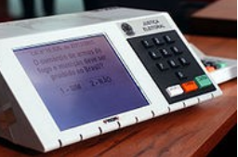

Figure 2.11: A DRE Voting Machine
An EVM which consists of two units, a control unit, and the balloting unit was designed for Indians elections. The two units are joined by a five-meter cable. Balloting unit facilitates voting by a voter via labeled buttons while the control unit controls the ballot units, stores voting counts and displays the results on 7 segment LED displays. The controller used in EVMs has its operating program etched permanently in silicon at the time of manufacturing by the manufacturer. No one (including the manufacturer) can change the program once the controller is manufactured. The control unit is operated by one of the polling booth officers, while the balloting unit is operated by the voter in privacy. The officer confirms the voter's identification then electronically activates the ballot unit to accept a new vote. Once the voter enters the vote, the balloting unit displays the vote to the voter, records it in its memory. A "close" command issued from the control unit by the polling booth officer registers the vote, re-locks the unit to prevent multiple votes. The process is repeated when the next voter with a new voter ID arrives before the polling booth officer.
The EVMs are powered by an ordinary 6 volt alkaline battery manufactured by Bharat Electronics Limited, Bangalore and Electronics Corporation of India Limited, Hyderabad. This design enables the use of EVMs throughout the country without interruptions because several parts of India do not have the power supply and/or erratic power supply. The two units cannot work without the other. After a poll closes on a particular election day, the units are separated and the control units moved and stored separately in locked and guarded premises.
We see the Kaduna State Local Government Area election of 2018. The Voter Verifiable Paper
Audit Trail (VVPAT) Electronic Voting Machine (EVM) Model number EMP2710 was built specifically for KAD-SIECOM (Kaduna State Independent Electoral Commission) by Chinese based EMPTECH; the same company that built handheld PVC scanners for the 2015 Nigerian presidential elections. Weighing in at 12kg, the EVMs are boxlike devices shaped like medium-sized printers.
They feature 1.8GHz quad-core processors, 2GB RAM, 8GB ROM, 12.2-inch LED backlit touch
display, USB 2.0, fingerprint scanner, SIM and PSAM (Secure Access Module) slots, 13,000mAH batteries and run on Android 5.1.
On the election day, voters go to respective polling units and get accredited with their permanent voters cards (PVCs). Afterwards, they electronically vote their chosen party and accompanying candidate by selecting and pressing the appropriate icon on the EVM screen.
When the voting exercise ends, an electoral officer brings out printed ballot papers from the machine for manual counting among party agents and officials.

2.2.1 SUMMARY OF THE REVIEWED LITERATURE
The e-voting systems we reviewed above were all developed out of quest to enhance the voting systems to meet the recent technological frame and as well provide a means to uphold a credible election. The different e-voting systems has different level of adoption of technology in them as seen fit by the authors and the users. Some e-voting systems use a single device with different authentication technology, while some implement two or more devices for authentication and vote casting purposes. Based on the technology available and the interest of the users, an e-voting device that works well is developed and there is always room for constant upgrade and development as technology advances.
The common criticism about the e-voting system is the issue of software security, and this has
poised a serious threat to the adoption of an e-voting system. In the quest to add a physical assurance to the e-voting systems, the VVPAT (Voter Verifiable Paper Audit Trail) was advocated to be adopted to allow for manual counting of votes also at the end of the election.

2.2.2 LITERATURE GAPS
The concept of e-voting systems has its focus on eliminating the issues of multiple voting and other election malpractice associated with the conventional ballot paper voting. Though many works have been done on the area of e-voting and many countries have adopted it for different levels of election, none of them was designed to completely captured the election process in Nigeria. The solution to the issues of voters traveling from one location to another where their vote would count on the Federal level elections is one missing puzzle to the existing e-voting systems.

CHAPTER THREE

METHODOLOGY

3.1 INRODUCTION
Methodology is the systematic, theoretical analysis of the methods applied to a field of study. The aim of this chapter is to give an introduction about the general research methodology and waterfall methodology for development used in this project. The formal approach of the facts finding of this project was using research, meetings, interviews, questionnaires, sampling, and other techniques to collect information about system problems, requirements, and preferences.

3.2 PRELIMINARY INVESTIGATION
In the information age, it seems that the application of information technology is an in-dispensable tendency for the evolution of organizations in 21st century, regardless of public or private organizations. The application of information technology into public affairs briefly includes the electronic democracy, which is governance-oriented, and e-government, which is service-oriented. E_Voting being a vital part of the services being offered by e-Government would lead the application of information technology to improve the efficiency of public sector obviously and the participation of the citizen through the electronic forum.
The purpose of this research is to identify the factors affecting the election process and ways they can be eliminated from the facts finding of the existing analysis of the system. There are two main research approaches used in scientific work, quantitative and qualitative. The main difference between these two is that the aim of quantitative research is to find explanation to a phenomenon or a situation that can be generalized to other people and places while in qualitative research the aim is to gain deeper understanding of a phenomena or a situation. Quantitative approach will be used to discover the issues that threaten the manual election process especially as it relates to voters. We are making use of existing data already collected by previous literature on elections to analyze the election process and derive a conclusion on how to eliminate the issues. The facts proved that the existing system possessed the identified problems which include high cost, time consuming, long queues and inaccurate result. Through implementation of this project all the above listed problems would be overcome.

3.3 FEASIBILITY STUDY
The Online Voting System calculates the results faster, reduces time spent making long queues at the polling stations during voting, reduces human efforts, and also enables voters to cast their votes from any part of the globe. Occurrences of vote miscounts was drastically reduced since at the backend of this system resides a well-developed database. It has several security requirements like access control as well as user authentication incorporated into its design structure, making it have a higher measure of security, reliability, and resilience. It also provides for user-friendly graphical interfaces and tools which make voting easy and enjoyable.

3.4 OVERVIEW OF THE EXISTING SYSTEM
Based on the reviewed data collected on previous conducted elections, the main issue with the election was the issue of voters apathy towards the electoral system which is as result of many factor such as inaccessible registration and voting venue, election violence that could lead to loss of lives, result manipulation and so on. A system that serves to increase voters participation in the electoral process is the remedy to these issues at hand. The existing system encompasses the use of ballot papers, election officers, polling units, materials to be distributed for the election.

3.5 ANALYSIS OF THE EXISTING SYSTEM
For a data to be gathered there must be a use of analysis tools. The tools used in this study was a qualitative analysis which is the used of descriptive data for example field note, interviews, video, audio, open ended survey questions and other stored records. All the votes in the existing system are to be casted manually by the voters on ballot papers. While before knowing the result, all the ballots papers must be counted one after the other as this will not take long time before knowing the final result of the election.

3.6 OVERVIEW OF THE PROPOSED SYSTEM
E-voting system serves to provide a remedy for the inaccessible registration and voting venue as eligible citizens can be registered and vote at their place of residence for their votes to count. It also provides a means to eliminate ballot box snatching as votes are counted as they are cast. There is also less room for result manipulation because the result get updated and displayed automatically.

3.7 ANALYSIS OF THE PROPOSED SYSTEM
All the data gathered was through qualitative analysis which makes use of previous field notes, meeting, interviews and questionnaire. The proposed system will have to eliminate the use of ballot papers during election, this will in return improve the technical and economical use activities in election.

3.8 SYSTEM DESIGN
In the design, some important design tools required to aid the development of the proposed system include use case diagrams, dataflow diagrams, flow charts and database design. The diagrams described that the admin have to manage a voter, candidates, election and result in the system, while the user can log in to the system and cast his vote. After the election, final result will be available where the user and the candidate can have direct access to it online.

3.8.1 USE CASE DIAGRAM
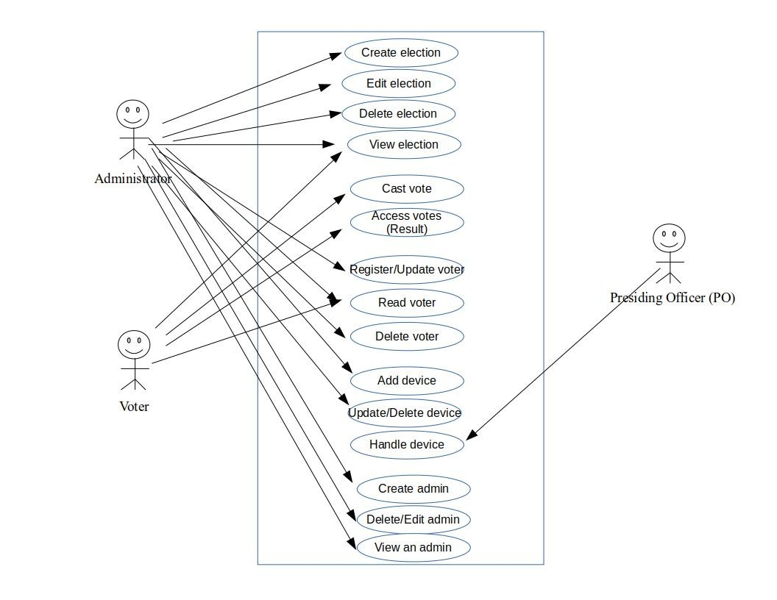
Server

Figure 3.0: Use case diagram

3.8.2 SEQUENCE DIAGRAM
Candidate
User
System
Admin

Manage voter
Manage candidate
Cast vote

View result
Set Election
View result
Print result

Figure 3.1: Sequence diagram

3.8.3 LOGICAL DESIGN
A logical ER model does not require a conceptual ER model, especially if the scope of the logical ER model includes only the development of a distinct information system. The logical ER model contains more detail than the conceptual ER model. In addition to master data entities, operational and transactional data entities are now defined.
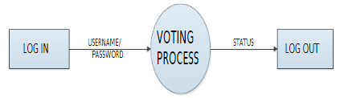

Figure 3.2: Level 0 Dataflow Diagram for Online Voting
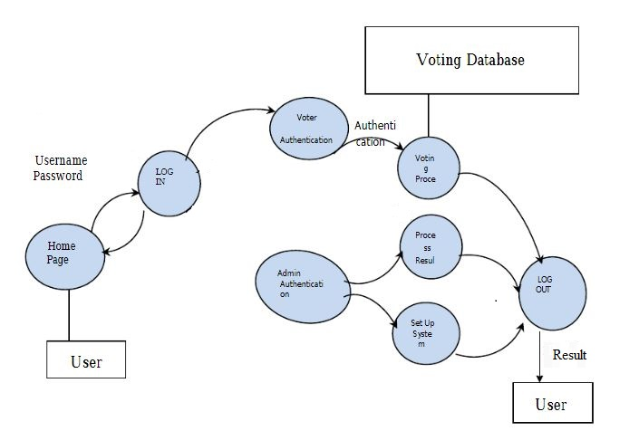

Figure 3.2: Level 1 Dataflow Diagram for Online Voting

3.8.4 PHYSICAL DESIGN
In physical design we will see how users add data to the system and how the system presents information back to the user; we will also see how data is modeled, validated, secured as it flows and also stored within the system. The best method to describe the above function is by using flowchart, algorithm. The description is shown below:
Algorithm System flowchart
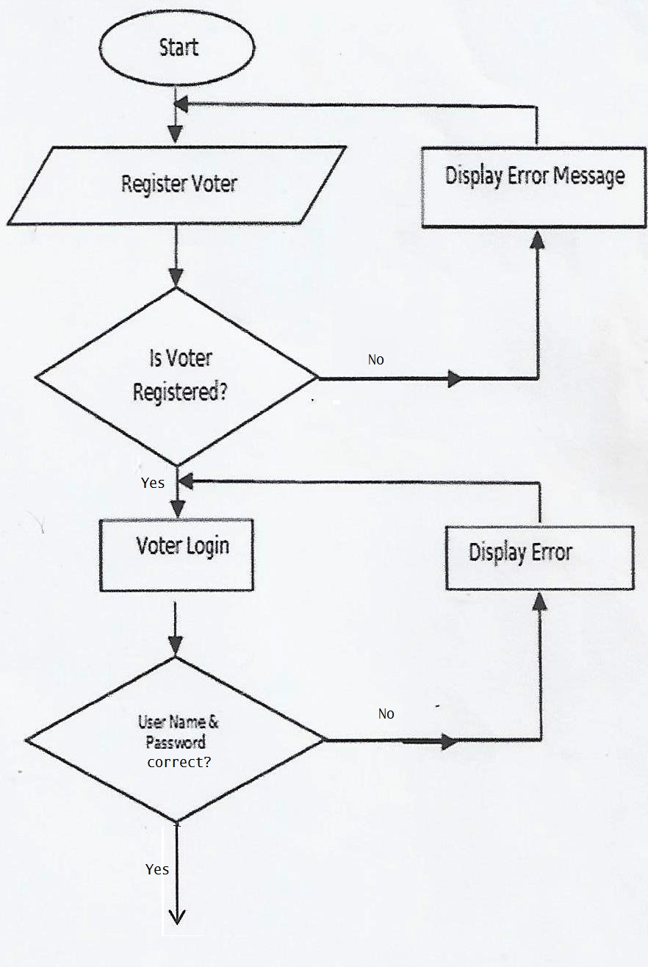
Register voter
Step 1: start
Step 2: input first name (a)
Step 3: input last name (b)
Step4: input password (c)
Step 5: Save= a + b + c
Step 6: Stored in database
Step 7: stop
Voter Login
Step 1: start
Step 2: input user ID
Step 3: input password
Step4: Authentication = true
Step 5: Display Voting page

No
No

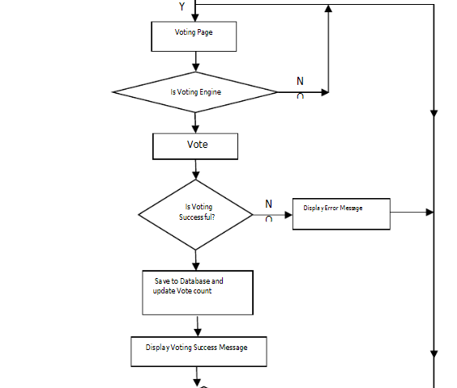

Voting page
Step 1: start
Step 2: input ID No.
Step 3: input password
Step4: select candidate
Step 5: cast vote
Step 6: save to database and update count
Step 7: Display result

No

No
Yes

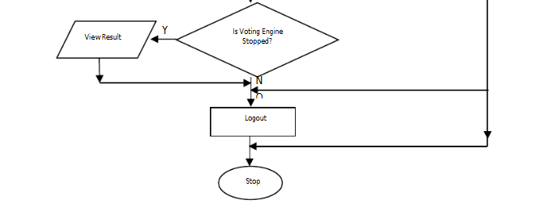
Yes

No

Figure 3.3: System Flowchart

3.8.5 DATABASE DESIGN
The Online Voting System uses a database called votesystem, below are the basic table of the system in the database.

Table 1: Admin Table
Field | Type | Null | Default | Primary | Auto Increment
Id | Int(11) |  |  | Yes | Yes
username | varchar(20)
password | varchar(20)
firstname | varchar(20)
Latstname | varchar(20)
photo | File
created_on | Date

Table 2: Candidate Table
Field | Type | Null | Default | Primary | Auto Increment
Id | Int(11) |  |  | Yes | Yes
Position_id | varchar(20)
Firstname | varchar(20)
Lastname | varchar(20)
Photo | File
Platform | varchar(20)

Table 3: Voters Table
Field | Type | Null | Default | Primary | Auto Increment
Id | Int(11) |  |  | Yes | Yes
voters_id | varchar(20)
Password | varchar(20)
Firstname | varchar(20)
Lastname | varchar(20)
Photo | file
Platform | varchar(20)

3.8.6 REQUIREMENTS ANALYSIS AND SPECIFICATION
The requirements for an e-voting system to be developed to model the Nigerian election at the Federal level and provide a remedy to voters’ apathy is itemized below as:
1. The system should contain four subsystem as listed below:
i. A software platform for administrative management purpose.
ii. User interface
iii. A software platform for result display.
iv. A database application for storage of election data.
2. The system should allow voters to be able to register against their place of origin from any place of residence or convenience.
3. The system should permit voters to be able to vote for their place of origin from any place of residence or convenience.
4. The system software platform should be accessible to all.
5. The system administrative dashboard for administrators should have access control.
The design of the system to meet the requirements above is depicted in the hardware block diagram as below:
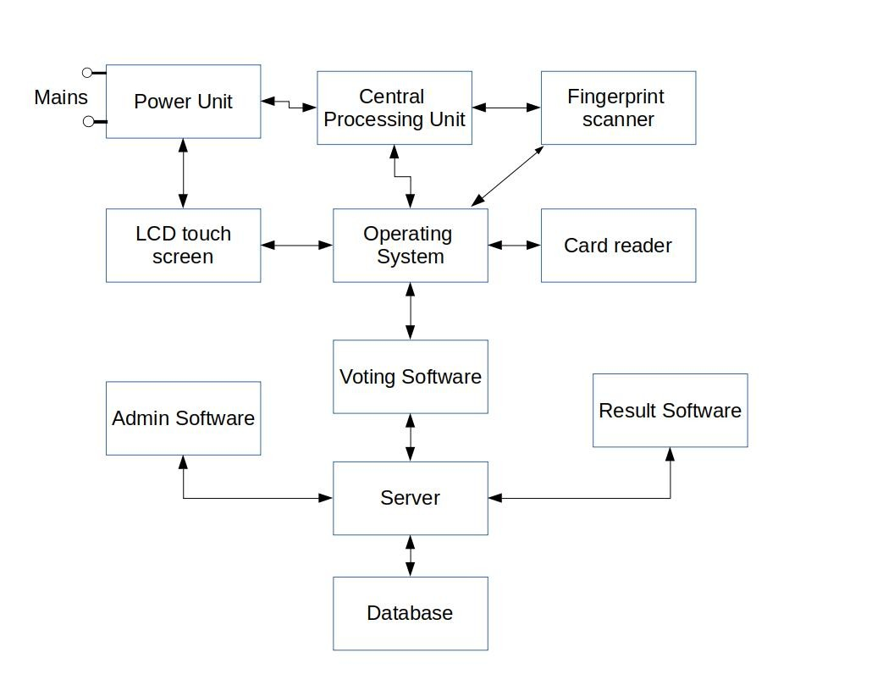
User Software

Figure 3.4: Hardware Block diagram
Voted
Processing

3.8.7 SOFTWARE DESIGN
The software consists of all the software platforms needed for the system functioning and their interactions. The figure below shows a block diagram of the software part of the system.
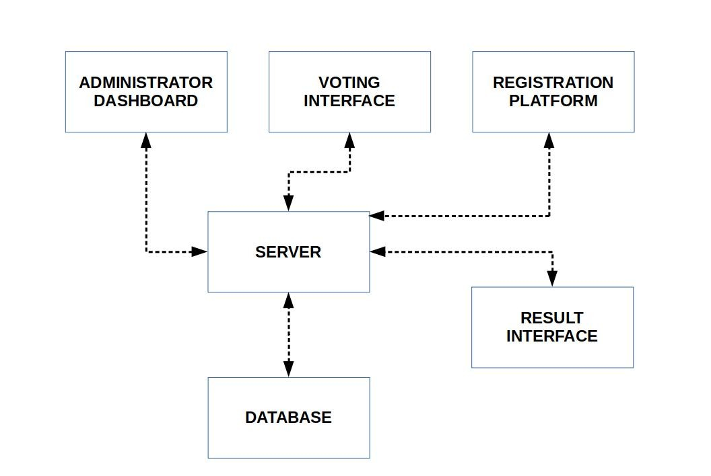

Figure 3.5: Software Design Block Diagram

CHAPTER FOUR

SYSTEM IMPLEMENTATION TESTING

4.1 INTRODUCTION
This chapter contained the implementation and testing of online voting system, the implementation stage confined how the logical design was implemented in to program code. System Testing entails the process of executing a program using a test data with the purpose of uncovering and correcting errors in the program.

4.1 SYSTEM IMPLEMENTATION
The system was developed as an interactive mechanism between the user interface, and the database using the web browser. It was designed using Micromedia Dreamweaver and Xamp server. These tools enable the admin and the user through a browser to interact with MySQL database to enter, edit, view, and retrieve data, as privilege granted. These activities were achieved using: PHP, CSS, Ajax and HTML forms which offer the best layout to enter, change and view from database. This form was also kept as short and simple as possible to suit the individual who will provide data.
The choice of programming used is top-down approach. This approach was used because the project arrangement was in linear format and linear format is always from top to-down to achieve a goal.

4.2 SYSTEM TESTING
After a system is developed, there is a need to test and verify that the system or program is “error free”, this refers to system testing. Black-box testing is a method of software testing that examines the functionality of an application without peering into its internal structures or workings. This method of test can be applied virtually to every level of software testing: unit, integration, system and acceptance. It is sometimes referred to as specification-based testing.

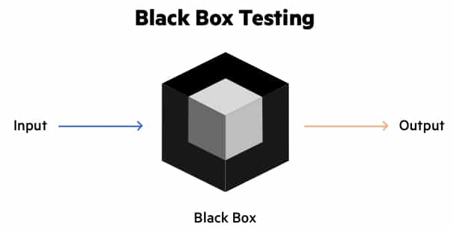
Figure 4.1: Black box testing
METHOD OF BLACK BOX TESTING
The table below tests the proposed system using black box testing in order to prove that the system yield what is expected from it.
1. Admin Dashboard
Input | Expected Output | Actual Output | Condition
Existing username  Correct password | Successful login | User login was successful
Existing username  Incorrect password | No login with error message | User can’t login. Error message: Incorrect login credentials
Successful login:  System management | Manage activities in the system | Manage voters, candidates, positions, elections, and result

2. User Dashboard
Input | Expected Output | Actual Output | Condition
Existing username  Correct password | Successful login | User login was successful
Existing username  Incorrect password | No login with error message | User can’t login. Error message: Incorrect login credentials
Cast Vote:  Successful login | Grant access to voting page | Cast vote
Already voted for election | Restrict user from multiple voting | Already voted

4.2.1 ADMINISTRATOR DASHBOARD
The administrator dashboard is a desktop software application managing the elections. It incorporates the basic CRUD (Create, Read, Update and Delete) features for monitoring and managing voters, administrators, elections and the voting devices. It accesses the server which for its data that are contained in the database. The administrator dashboard has a login page as shown below to restrict unauthorized access to the dashboard. The login will require username and password for authentication and validates it against the values in the database. If validation succeeds, access to the dashboard is granted, else he/she is restricted. Below are the name of some pages and their functions in the system:
1. Admin Login Page: this is the first step where an admin can input his username and password.
2. Admin Dashboard: This is where admin can manage voters, candidates, set election, and print result.
3. Add new voter: this is a form where a new voter can be added by the admin. This is where the voters are registered prior to an election. The registration software application has features to enable the registration of voters, which involves collecting voters data and storing the data in the database through the server.
4. Add candidate: this is where a new candidate can be added by the admin
5. Add Position: this is the form where an admin can add new position for the election
6. Configure election: this is a form where an admin can set a new election
7. User Login form: This is the form where a user is required to input his Id No. and password before login to his dashboard.
8. Voting Interface: This is the page where a voter can select his candidate. The figure below shows that the voter selected Abubakar Hassan as Governor in 2022 election.\
9. Successful submission: this page shows that the voter has successfully submitted his ballot in the election.
10. Election Result: this is the final result of election showing the candidates and the number of voters voted for them in each position.

CHAPTER FIVE

SUMMARY, CONCLUSION AND RECOMMENDATION

5.1 SUMMARY
The manual system of voting in Nigeria has failed to tackle the basic issues necessary for a clean and trusted voting environment which has evidently driven some of its citizens to apathy. The E-voting system was implemented to solve the proximity bottlenecks, unnecessary time delays, with very secure and accurate recording of votes. The system has been thoroughly tested in voting accuracy, ruggedness, responsiveness, battery life expectancy, and security by means of simulation and mini voting sessions to be a successful one. It is seen that the system is fault tolerant at all end points (registration, voting platform and the server).
The voting device can last for more than 6 hours which is very sufficient for a quick system like ours. This system will provide boundless voter participation in remote areas with very little or no cost on the
voter greatly reducing apathy. Further improvements can be done on the system to increase the credibility of the votes and further reduce proximity issues.

5.2 CONCLUSION
This paper has come as a platform to propose an online voting system that will place our democracy on a path of success. In a nutshell, this research seeks to increase the efficiency of voting process and the image of the Electoral Commissions in charge of elections. This Online Voting System is simple and indigenous. It has an authentication feature that will manage the Voter’s information by which voter can login and use his/her voting rights. There is a database in which all the names of voters with complete information is stored and it provides the tools for maintaining voter’s vote to every candidate and also computes the total number of votes of every candidate. Online voting offers speed and convenience to the voter and considerable ease to election administrators as they can get election results out more quickly than conventional methods of manual voting since vote counting is just a matter of querying the database.

5.3. RECOMMENDATION
The following recommendations are made for optimal performance of the system:
1. Further research should include the use of finger print in order to improve authentication
2. Two-factor authentication should be used to improve security.

REFERENCE
ACE, E-voting, The Electoral Knowledge Network, n.d., [Online]. Available: http://aceproject.org/ace-en/focus/e-voting/default. [Accessed: Aug. 07, 2019].
Alexandra Dmitrienko, Christopher Liebchen, Christian Rossow, and Ahmad-Reza Sadeghi “On the
(In) Security of Mobile Two-Factor Authentication” Lecture Notes in Computer Science, pp. 365-383,
Nov 2014.
Alexandra Petru , What is two-factor authentication (2FA)?, iPhone Backup Extractor, Oct. 08, ș, What is two-factor authentication (2FA)?, iPhone Backup Extractor, Oct. 08,
2017, [Online]. Available: http://www.iphonebackupextractor.com/blog/2016/jun/3/extract-data-twofactor-authentication/. [Accessed: Aug. 11, 2019].
Alireza Pirayesh Sabzevar, Angelos Stavrou “Universal Multi-Factor Authentication Using Graphical Passwords”, Proceedings of the 2008 IEEE International Conference on Signal Image Technology and Internet Based Systems. pp. 625-632, 2008.
CardLogix Corporation, Smart Card Basics, CardLogix Corporation, 2010. [Online] Available from: http://www.smartcardbasics.com [Accessed 1/05/19].
Jason Cipriani, Seth Rosenblatt, Two-factor verification: What you need to know (FAQ), CNET,
June 15, 2015, [Online]. Available: https://www.cnet.com/news/Evoting-[Accessed: Aug. 10, 2019].
Olufemi Sunday Adeoye “Evaluating the Performance of two-factor authentication solution in the
Banking Sector” IJCSI International Journal of Computer Science Issues, Vol. 9, Issue 4, No 2, July 2012.
Paul David Webb, roger Gibbins, Heinz, Eulau, “election”, encypclopaedia Britannica. [Online]. Available: https://www.britnnica.com/topic/election-political-science. [accessed: aug. 05, 2019].
Rahul Kale, Neha Gore, Kavita, Nilesh Jadhav, Swapnil Shinde “ Review Paper on Two Factor Authentication Using Mobile Phone” International Journal of Innovative research and Studies, Vol. 2,
Issue 5, pp. 164 - 170, May 2013.
Seth Rosenblatt, Jason Cipriani, Two-factor authentication: What you need to know (FAQ), CNET,
June 15, 2015, [Online]. Available: https://www.cnet.com/news/two-factor-authentication-what-youneed-to-know-faq. [Accessed: Aug. 10, 2019].
Tarun Agarwal, How does the Smart Card Works?, ElProCus, n.d. [Online] Available from:
van Tilborg, Henk C.A.; Jajodia, Sushil, eds. (2011). Encyclopedia of Cryptography and Security,
Volume 1. Springer Science & Business Media. p.1305.
van Tilborg, Henk C.A.; Jajodia, Sushil, eds. (2011). Encyclopedia of Cryptography and Security,
Volume 1. Springer Science & Business Media. p.1305.
Victor Ekwealor, Inside Nigeria’s first ever electronic voting exercise in Kaduna State, Techpoint Africa, May 14, 2018, [Online]. Available: https://techpoint.africa/2018/05/14/kaduna-electronicvoting/. [Access: Aug. 10, 2019].

`

APPENDIX A
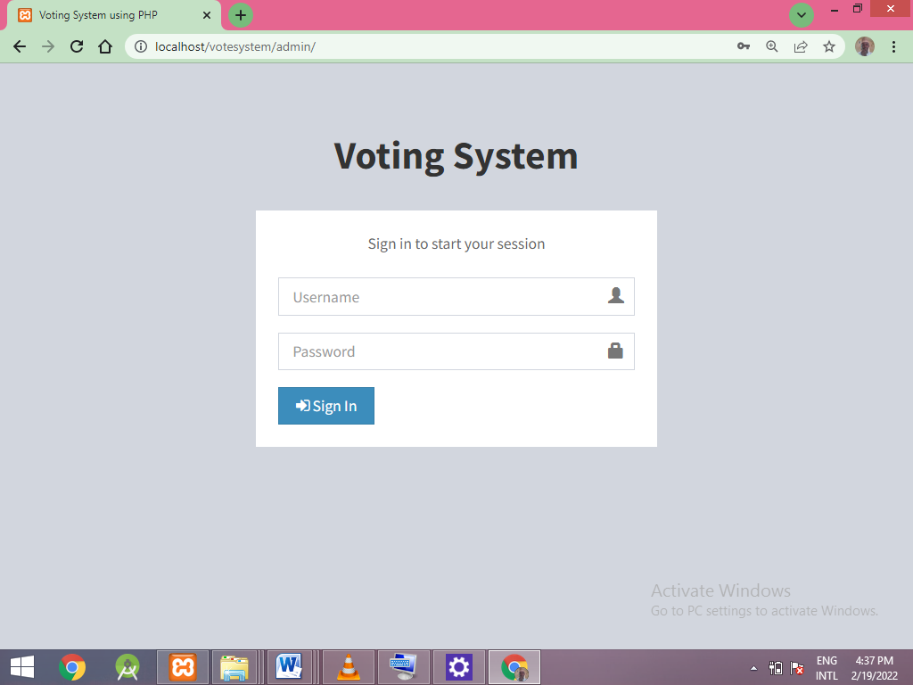
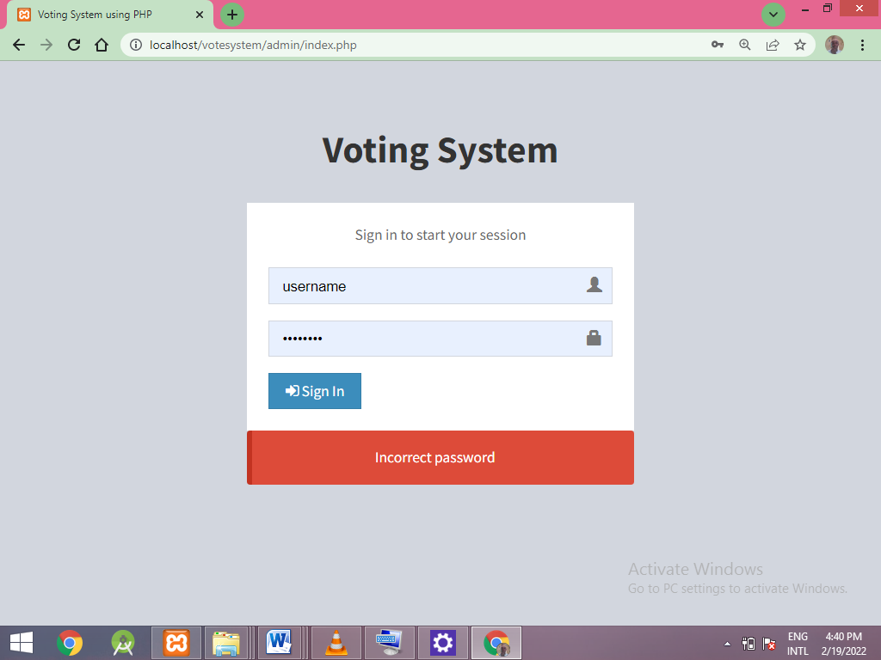
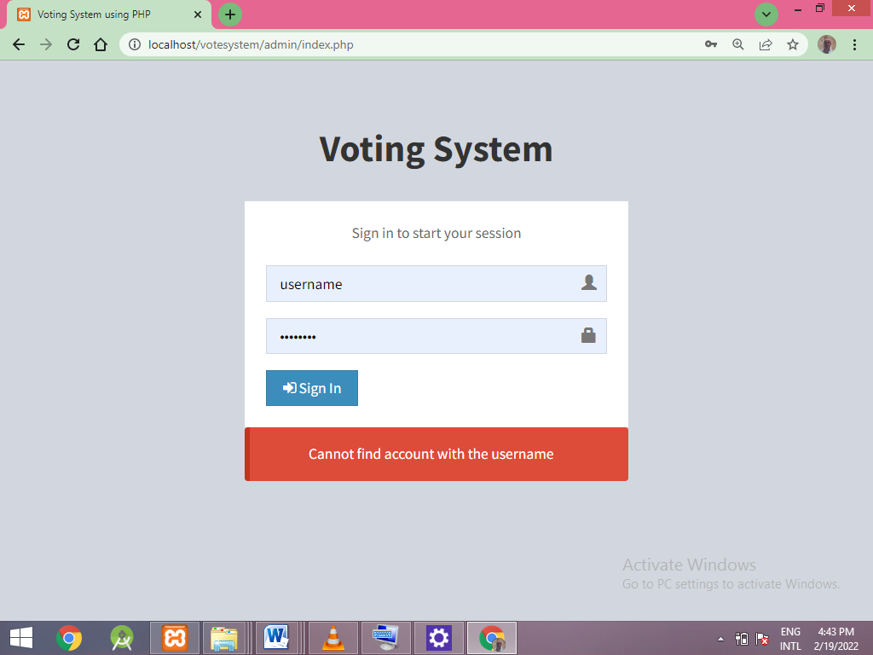
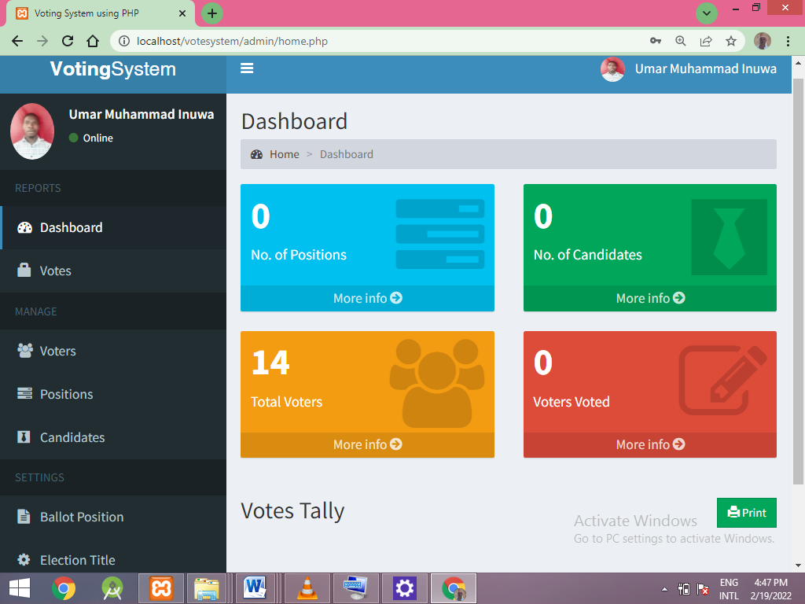
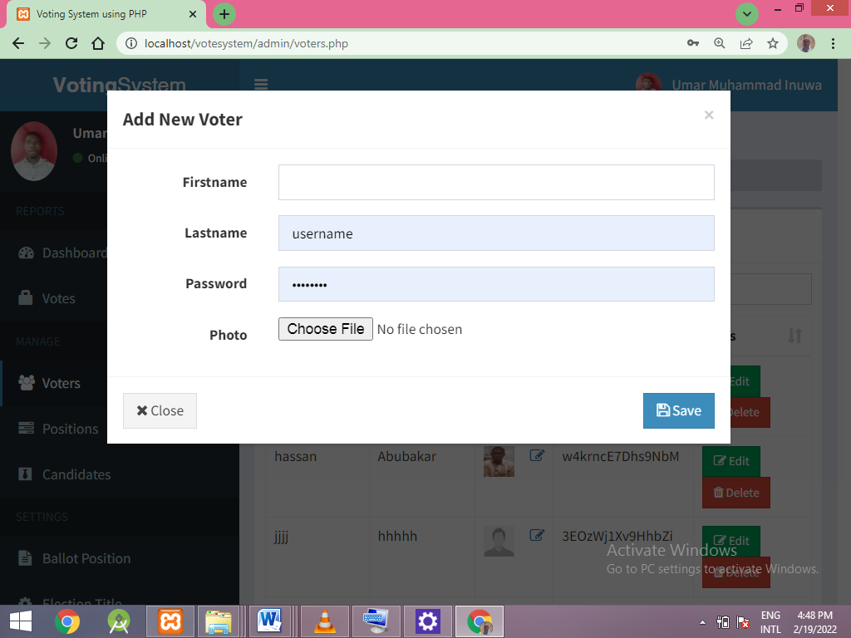

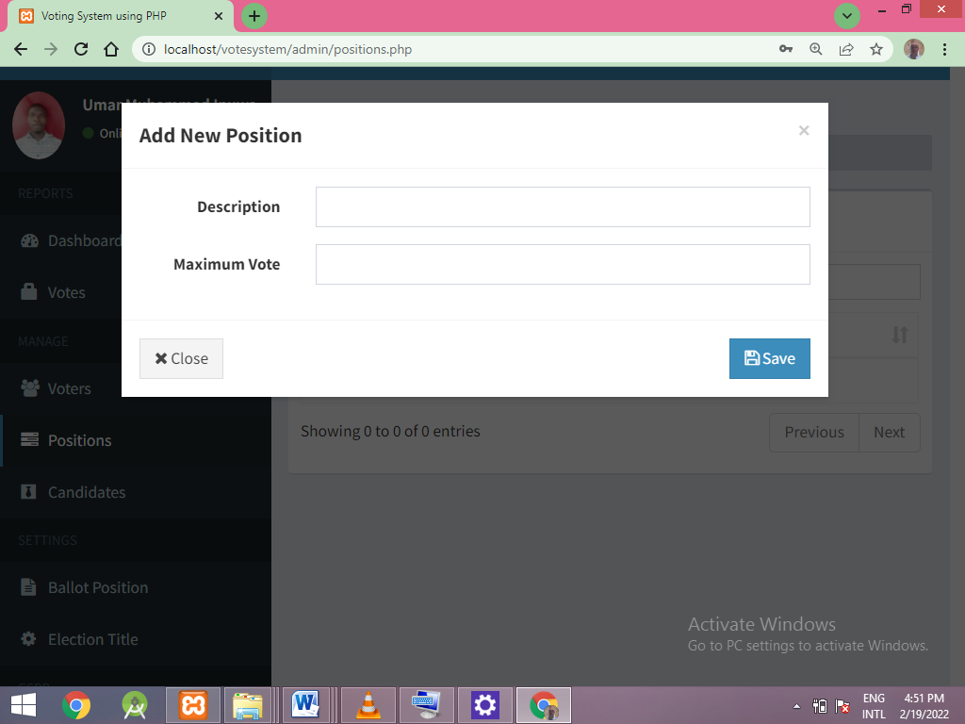

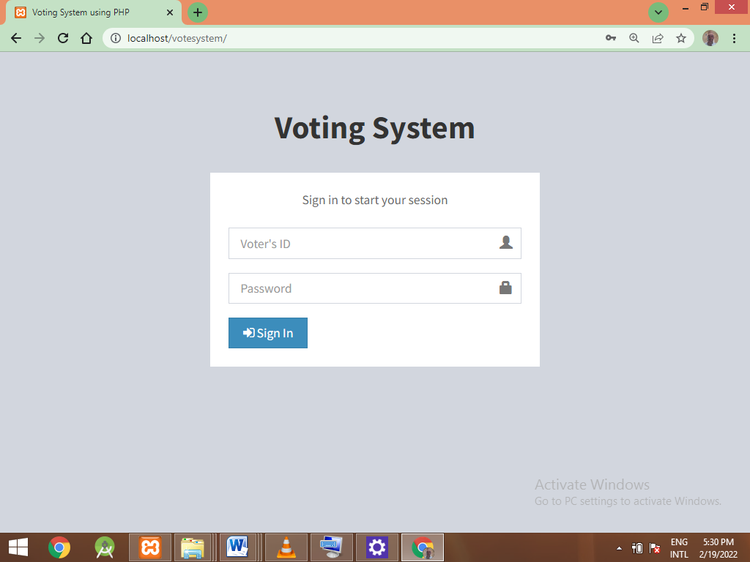


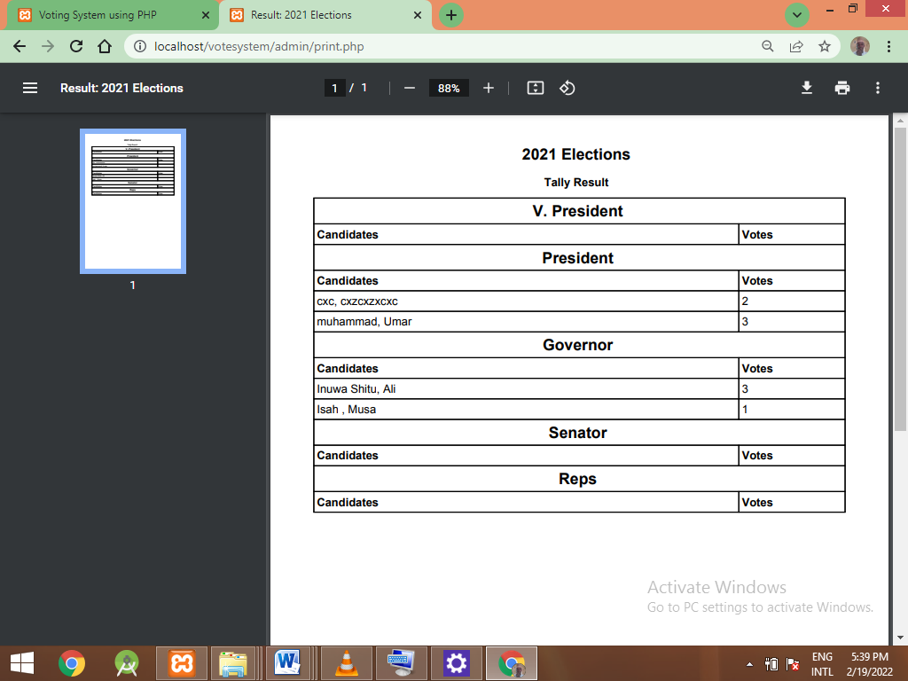

APPENDIX B
<?php
session_start();
if(isset($_SESSION['admin'])){
header('location: admin/home.php');
}

if(isset($_SESSION['voter'])){
header('location: home.php');
}
?>
<?php include 'includes/header.php'; ?>
<body class="hold-transition login-page">
<div class="login-box">
<div class="login-logo">
<b>Voting System</b>
</div>

<div class="login-box-body">
<p class="login-box-msg">Sign in to start your session</p>

<form action="login.php" method="POST">
<div class="form-group has-feedback">
<input type="text" class="form-control" name="voter"
placeholder="Voter's ID" required>
<span class="glyphicon glyphicon-user form-control-
feedback"></span>
</div>
<div class="form-group has-feedback">
<input type="password" class="form-control"
name="password" placeholder="Password" required>
<span class="glyphicon glyphicon-lock form-control-feedback"></span>
</div>
<div class="row">
<div class="col-xs-4">
<button type="submit" class="btn btn-primary
btn-block btn-flat" name="login"><i class="fa fa-sign-in"></i> Sign In</button>
</div>
</div>
</form>
</div>
<?php
if(isset($_SESSION['error'])){
echo "
<div class='callout callout-danger text-center mt20'>
<p>".$_SESSION['error']."</p>
</div>
";
unset($_SESSION['error']);
}
?>
</div>
<?php include 'includes/scripts.php' ?>
</body>
</html>

